Only the phone call or Microsoft Authenticator by notification works for remote access. You can change your authentication method through MyApps using the following steps:
In your Internet browser, go to staff.swansea.ac.uk and login. After logging in click on your name in the right-hand corner and choose MyApps from the drop-down.
Choose the option for Secure My Account
You will be prompted by your MFA method again. This is expected as you are changing security information.
Under Security Info you will see the current options you have registered for MFA.
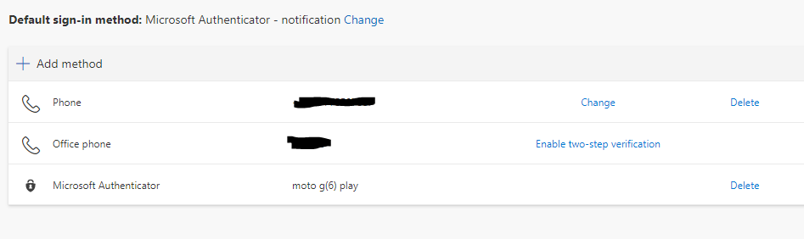
You can either use Add method to add a new method of authentication, or if you already have an appropriate method listed, you can click Change next to your Default sign-in method to set the default prompt to either phone call or Microsoft Authenticator – notification. You can then return to your remote desktop settings and login using the new method.

